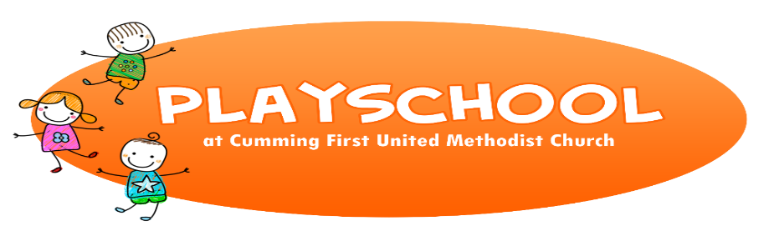
CFUMC Playschool Registration Form
September 2021 - May 2022

HOURS: 8:00 a.m. - 12:30 p.m.
DAYS: Monday, Tuesday, Wednesday & Thursday
AGES: 6 months to children under 2 by Sept. 1st (must turn 2 after Sept 1st) \

IMPORTANT DATES:
Playschool Open House – Thursday, August 26th, 2021 – 9:00 am -5:00 pm
* a link will be emailed to sign up for a private 15-time slot

TUITION ANNUAL REGISTRATION FEE (non-refundable)
1 day / week = $120.00 / month $80.00
2 days / week = $200.00 / month $120.00
*FIRST TUITION PAYMENT IS DUE IN SEPTEMBER BY THE 10TH

ANNUAL SUPPLY FEE = $75.00 (non-refundable) MUST BE PAID BY SCHOOL START DATE
- Fee covers crafts, baby wipes, cleaning supplies and light snacks

Make check payable to: CFUMC Playschool

PERSONAL INFORMATION

Child’s Name: _____________________________________ Child’s DOB: _____/_____/_____

Parent /Guardian’s Name: ____________________________ Cell Phone: (__________) ______

Parent /Guardian’s Name: _____________________________ Cell Phone: (__________) ______

Address: _______________________________ City: ________________ Zip: _______________

Home Phone: (_______) __________________________________________________________

Parent’s Email: __________________________ Parent’s Email: _________________________

Emergency Contact: Name ___________________________ Phone: (________)____________

DAY(s) PREFERENCE

1st choice (circle): MON TUES WED THURS

2nd Choice (circle): MON TUES WED THURS

# of Days requested: __________ TODAY’S DATE: ____/_____/____

I understand that Playschool is not a licensed program.

_______________________________ ________________________________ __________
PARENT’S NAME PARENT’S SIGNATURE DATE

TO BE COMPLETED BY STAFF: START DATE: _____/_____/_____

REGISTRATION FEE $_________ DATE PAID: ___/___/____ CK#:_________ MEDICAL FORM: ________
1st MONTH TUITION: $_________ DATE PAID: ___/___/____ CK#:_________ IMMUNIZATION FORM: ________
SUPPLY FEE: $_________ DATE PAID: ___/___/____ CK#:_________ PICK UP / DROP OFF FORM: ________

